Office of the Superintendent  P.O. Box 125  205 Main Street  Gatesville, NC 27938  (252) 357-1113  Dr. Phillip Barry Williams  Superintendent | 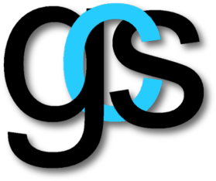  Gates County Schools | BOARD MEMBERS  Chair  Sallie J. Ryan  Vice-Chair  Ray Felton  Members  Leslie Byrum  Terri Riddick  Ronnie Riddick

Gates County Community Partners Application

Organizations wishing to be designated as a Gates County Schools Community Partner must submit this application to confirm their eligibility. A Community Partner is defined as an organization that contributes volunteer time, resources, and/or funding to support the school system's goal of working together with students, parents, and the community to provide an exceptional education that helps develop students of strong character, ready for the future.

Name of Organization: __________________________________________________
Address of Organization: _______________________________________________________________________

City: ________________________ State: ____ Zip: ______________
Contact Person Name: _______________________ Contact Phone #:____________
Contact Person email address: ________________

Kindly provide a comprehensive list of the activities and contributions (including educational, material, and financial support) that your organization has made to the Gates County School System or the Gates County Community. Please highlight the ways in which your organization's efforts align with the qualifications for becoming a designated Community Schools Partner. If needed, feel free to attach additional sheets to provide further details:

